**Final Project Database System CIS402G**

**Joshua Troup**

**Part I – Design the Database (4 Parts)**

**Part II – Implement the Database**

**Part III – Query the Database**

**Part I: #1**

**#2 (Next page)**

Course (code, title, duration, idDepartment)

Primary key: code

Alternative key:

Foreign key: idDepartment references department(idDepartment)

Module (code, title, startDate, endDate, coursework, exam, idCoordinator, idCourse)

Primary key: code

Alternative key: title, startDate, endDate, idCourse

Foreign key: idCoordinator references Staff(staffID)

idCourse references Course (code)

References (code, title, text, link)

Primary key: code, title

Alternative key:

Foreign key: code references Module (code)

Departments (idDepartment, name, phone, fax, location, idManager, dateStart)

Primary key: idDepartment

Alternative key: name

Foreign key: idManager references Staff(staffID)

Staff (idStaff, firstName, lastName, extPhoneNumber, office, sex, salary, post, qualifications, address, idDepartment, idCourseCoordinated, netID)

Primary key: idStaff

Alternative key:

Foreign key: idDepartment references Department (idDepartment),

idCourseCoordinated references Course (code),

netID references net (netID)

Teach (idModuleTeach, idStaff, code)

Primary key: idModuleTeach

Alternative key: idStaff, code

Foreign key: idStaff references Staff(staffID)

code references Module (code)

TeachWeek (idModuleTeach, date, hours)

Primary key: idModuleTeach, date

Alternative key:

Foreign key: idModuleTeach references Teach(idModuleTeach)

Student (idStudent, firstName, lastName, town, street, postCode, dateBirth, sex, financeLoan, emergyName, emergyAddress, phone, netID)

Primary key: idStudent

Alternative key: firstName, lastName, dateBirth

Foreign key: netID references net (netID)

Enroll (idStudent, idNumber, idCourse, dateEnroll)

Primary key: idNumber

Alternative key: idStudent, idCourse, dateEnroll

Foreign key: idStudent references Student (idStudent)

idCourse references Course (code)

Pass(idNumber, idModule, CourseWork, dateCourseWork, Exam, dateExam)

Primary key: idNumber, idModule

Alternative key:

Foreign key: idNumber references Enroll (idNumber)

idModule references Module (idModule)

**#3**

**Course**

|  |  |  |  |
| --- | --- | --- | --- |
| **Code** | **title** | **duration** | **idDepartment** |

**Module**

|  |  |  |  |  |  |  |  |
| --- | --- | --- | --- | --- | --- | --- | --- |
| **Code** | **title** | **startDate** | **endDate** | **CourseWork** | **exam** | **idCoordinator** | **idCourse** |

**References**

|  |  |  |  |
| --- | --- | --- | --- |
| **Code** | **title** | **text** | **link** |

**Departments**

|  |  |  |  |  |  |  |
| --- | --- | --- | --- | --- | --- | --- |
| **idDepartment** | **name** | **phone** | **fax** | **location** | **idManager** | **dateStart** |

**Staff**

|  |  |  |  |  |  |  |  |  |  |
| --- | --- | --- | --- | --- | --- | --- | --- | --- | --- |
| **idStaff** | **FirstName** | **lastName** | **extPhoneNumber** | **office** | **sex** | **salary** | **post** | **qualifications** | **address** |

**Staff table continued:**

|  |  |  |
| --- | --- | --- |
| **idDepartment** | **idCourseCoordinated** | **netID** |

**Teach**

|  |  |  |
| --- | --- | --- |
| **idModuleTeach** | **idStaff** | **code** |

**Teaches Week**

|  |  |  |
| --- | --- | --- |
| **idModuleTeach** | **date** | **Course** |

**Student**

|  |  |  |  |  |  |  |  |  |  |
| --- | --- | --- | --- | --- | --- | --- | --- | --- | --- |
| **idStudent** | **firstName** | **lastName** | **town** | **street** | **postcode** | **dateBirth** | **sex** | **financeLoan** | **emergyName** |

**Student table continued:**

|  |  |  |
| --- | --- | --- |
| **emergyAddress** | **Phone** | **netID** |

**Enroll**

|  |  |  |  |
| --- | --- | --- | --- |
| **idStudent** | **idNumber** | **idCourse** | **dateEnroll** |

**Pass**

|  |  |  |  |  |  |
| --- | --- | --- | --- | --- | --- |
| **idNumber** | **idModule** | **CourseWork** | **dateCourseWork** | **Exam** | **dateExam** |

**#4**

|  |  |  |  |  |  |  |  |
| --- | --- | --- | --- | --- | --- | --- | --- |
| **matricNo** | **Name** | **Sex** | **moduleTitle** | **modulestartDate** | **Performance** | **flatNo** | **address** |

**Module (moduleTitle, module startDate), primary key: moduleTitle**

**Pass (matricNo, moduleTitle, performance), primary key: matricNo,moduleTitle;**

**Student (matricNo, name, sex, moduleTitle, flatNo, address).**

**Part II:**

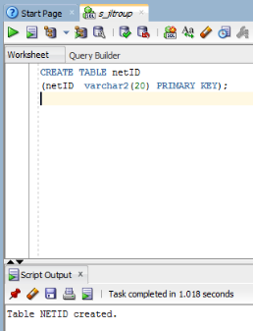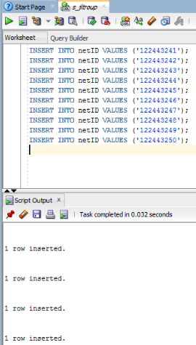

**netID table and values**

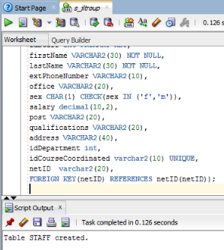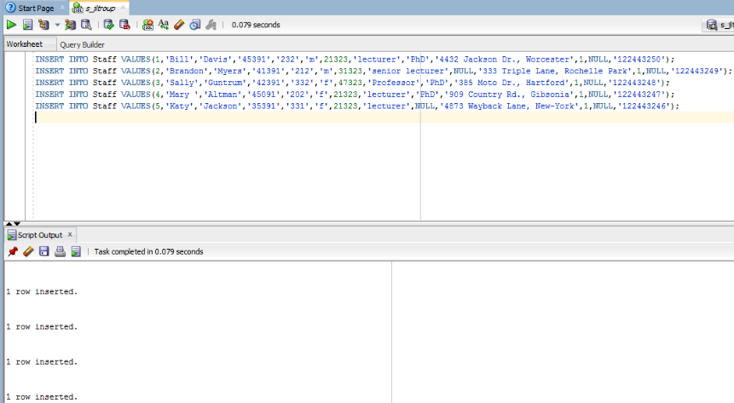

**Staff tables and values**

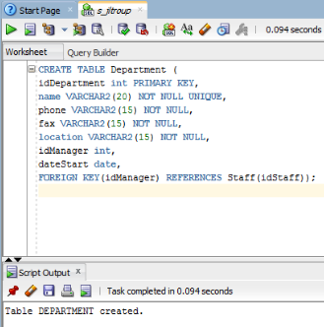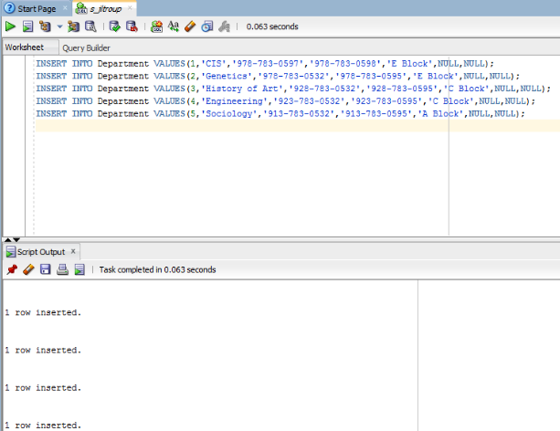

**Department table and values**

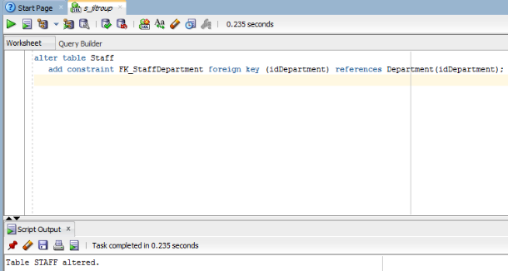

**Department constraint added to Staff table**

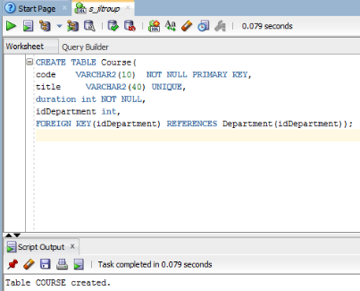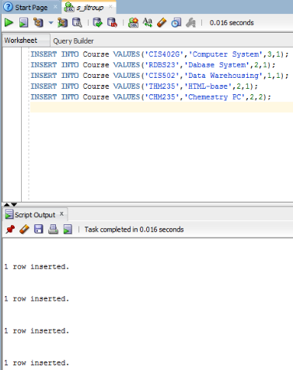

**Course table and values**

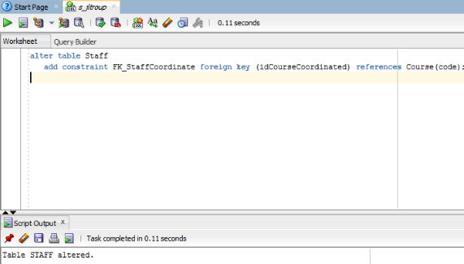

**Course constraint added to Staff table**

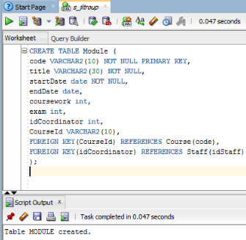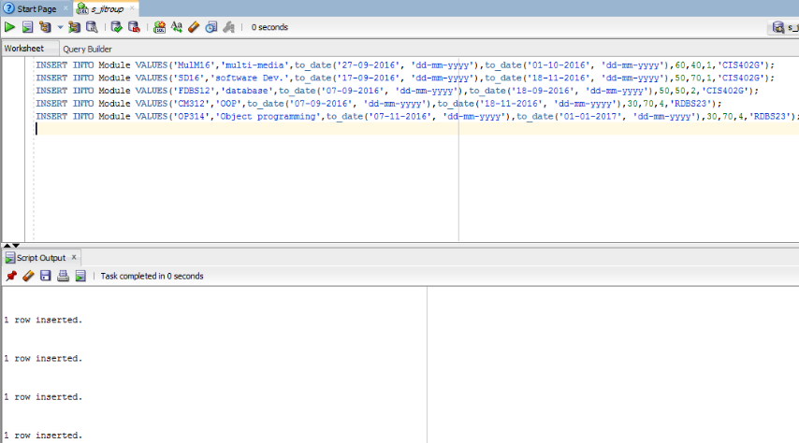

**Module table and values**

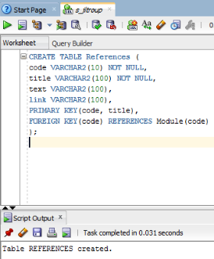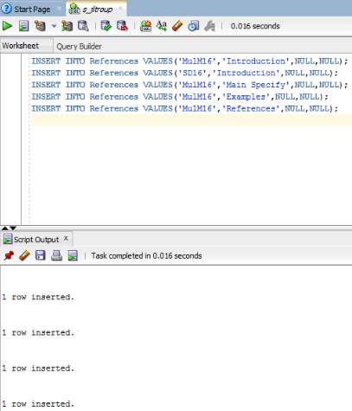

**References table and values**

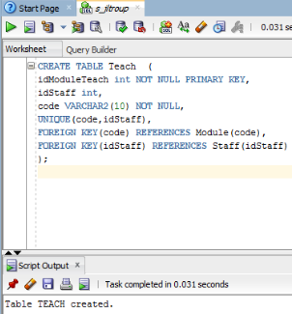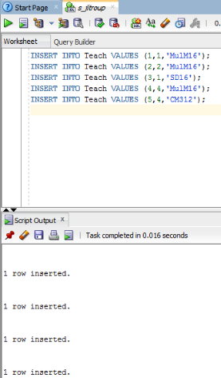

**Teach table and values**

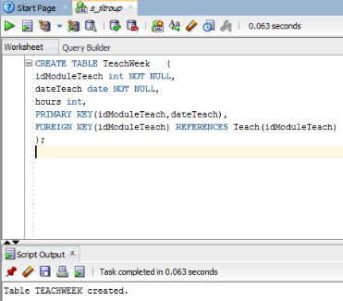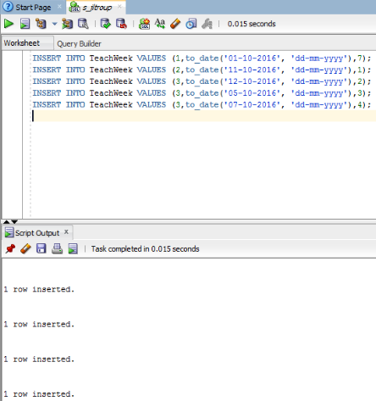

**Teachweek table and values**

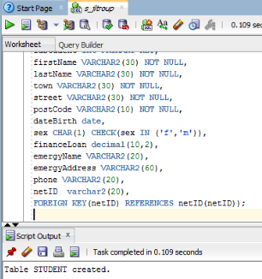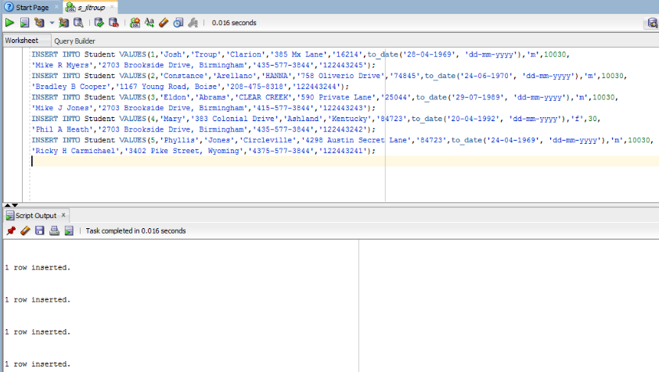

**Student table and values**

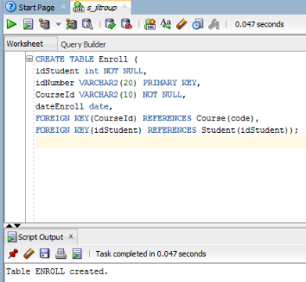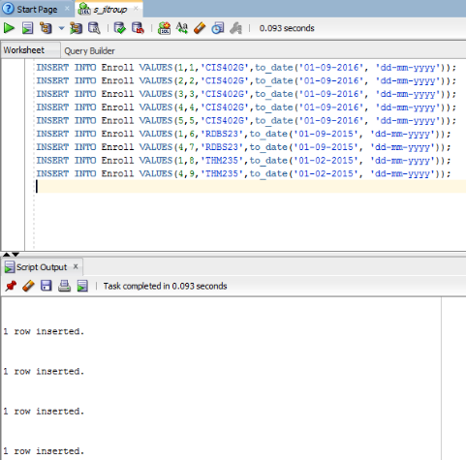

**Enroll table and values**

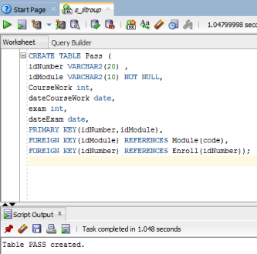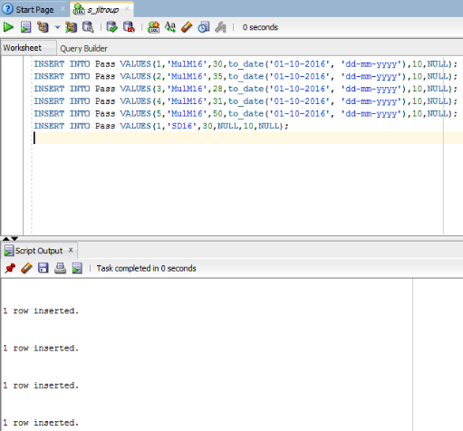

**Pass table and values**

**Part III:**

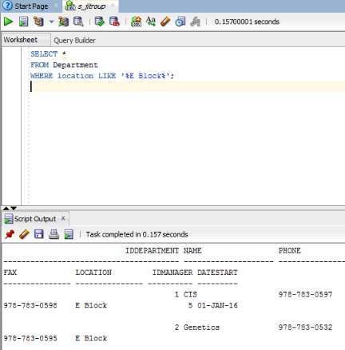

**1.**

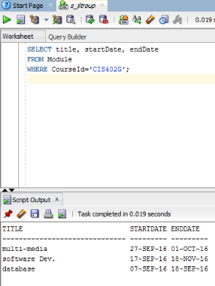

**2.**

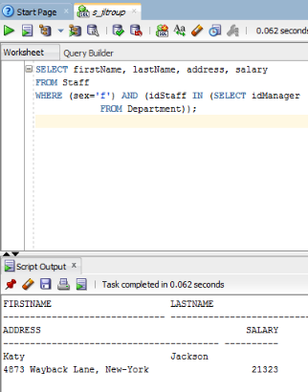

**3.**

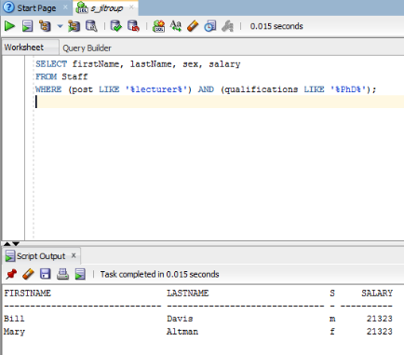

**4.**

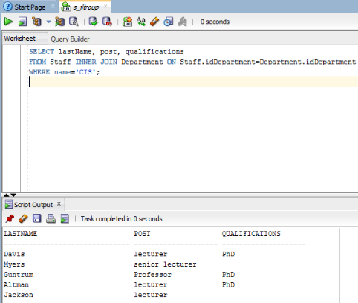

**5.**

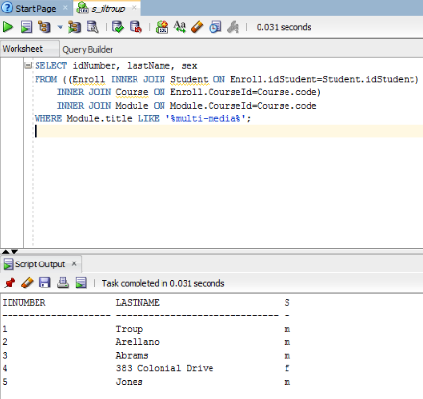

**6.**

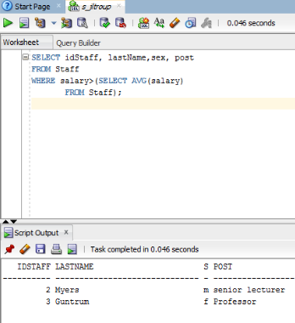

**7.**

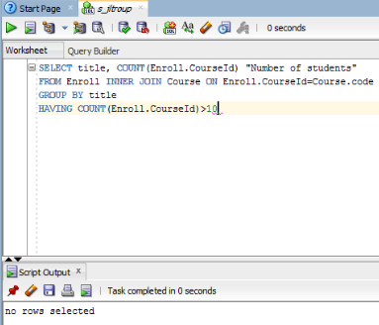

**8.**

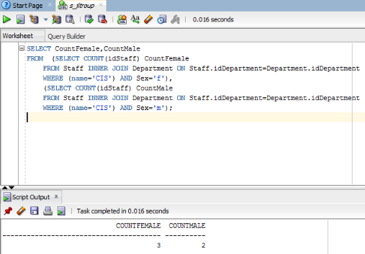

**9.**

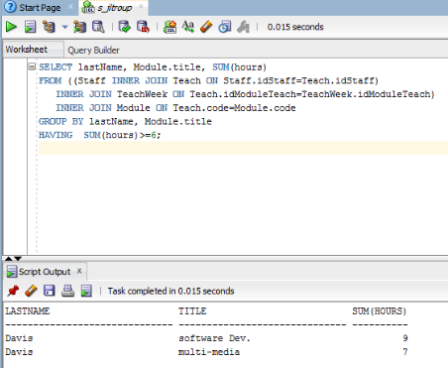

**10.**